Beginning of Lab 8 to fetch and decode the code.
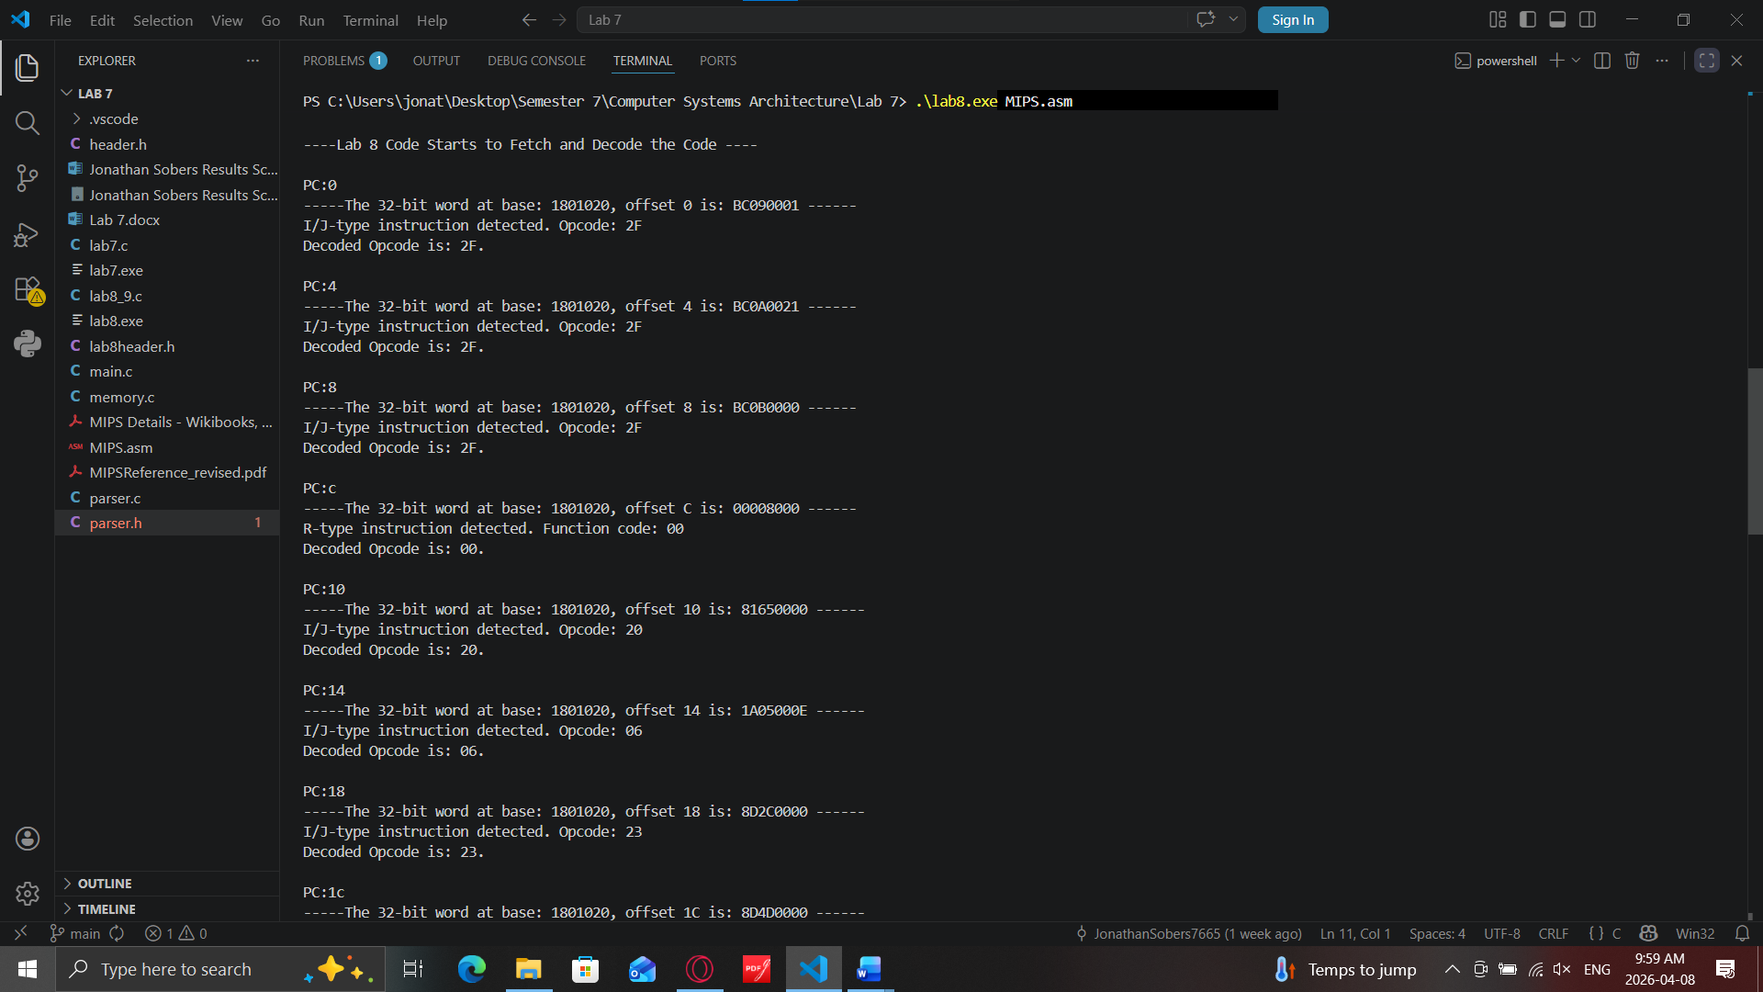
2nd screenshot showing the finished section of fetch and decode the code
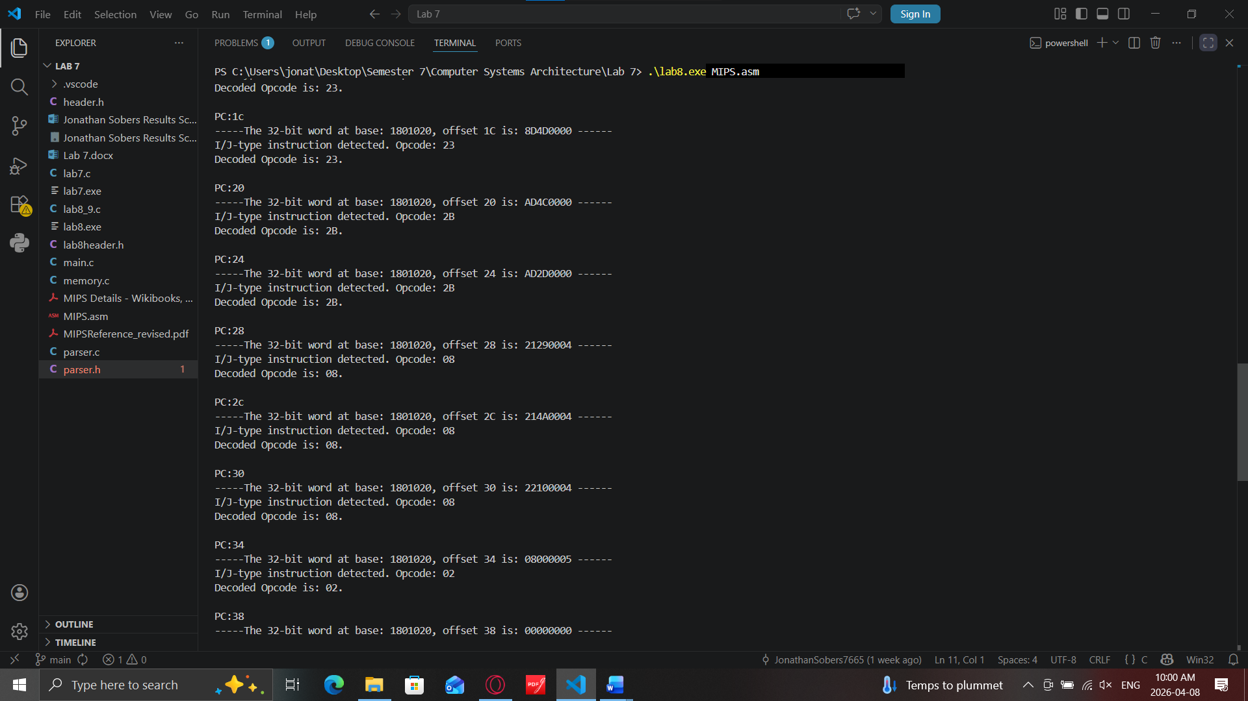

Screenshot showing the Register file dump organized into 1 organized line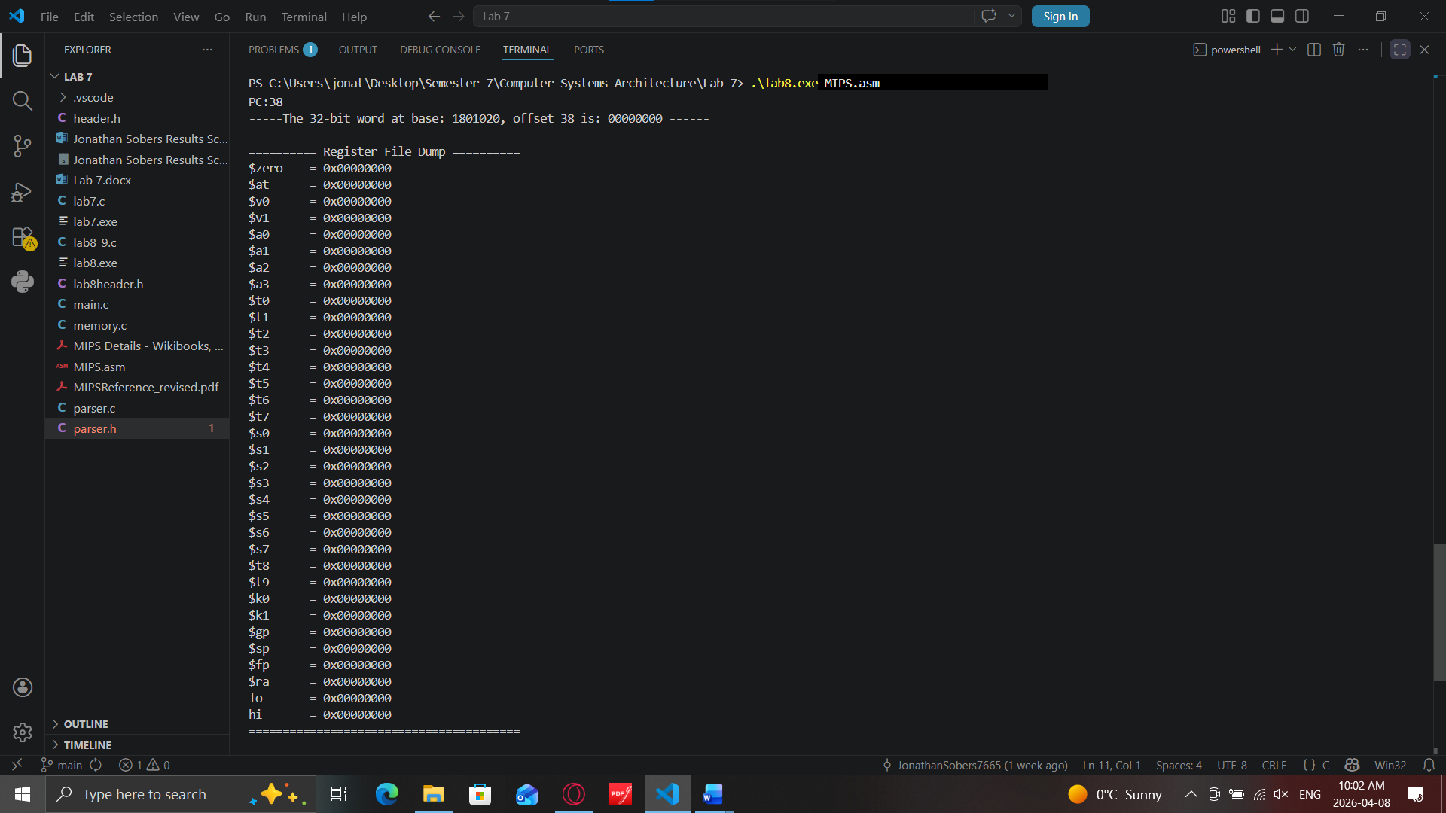
Final Screenshot showing the Data section Memory Dump
